Alert Notification System Using Arduino Uno

Jairo Bersamina Ponce (Student)

Faculty of Department of Computer Engineering, College of Engineering, Architecture and Industrial Design, Bohol Island State University-Main Campus, Jairo.ponce@bisu.edu.ph

Max Angelo Dapitilla Perin (Instructor)

Faculty of Department of Computer Engineering, College of Engineering, Architecture and Industrial Design, Bohol Island State University-Main Campus, maxangelo.perin@bisu.edu.ph

Overheating, voltage regulation failure, arc flash, and shock are all hazards that might result in death or even fire if you are exposed to them. Fortunately, the likelihood of this occurring is extremely remote. This research presents an Arduino-based system for controlling and monitoring electrical devices and sensors remotely for power conservation and protection. Unexpected power failures can result in a power surge, which can harm equipment or electronics while also generating high voltage electricity. A plug remover device is provided in this study, with the goal of controlling and monitoring family consumption via a mobile application or computer. People may stay on top of the information that matters to them thanks to alerting. A notification system is usually used to give alerts. The device is Global System for Mobile communication (GSM) alert notification system-enabled and uses an Arduino Uno and other components to send SMS alert notifications. The research yielded a substantial finding that has a favorable impact on a household's energy consumption rate. Furthermore, the device makes an important theoretical contribution by including the environmental concern such as the safety when dealing with electricity.

CCS CONCEPTS • Hardware • Communication Hardware, interface and storage • Signal processing Systems • Digital processing Systems

Additional Keywords and Phrases: GSM alert notification system, Electrical safety, Arduino Uno

ACM Reference Format:

**Jairo Bersamina Ponce**, Max Angelo Dapitilla Perin. 2022. **Alert-Notification System using Arduino Uno**. In Research Project Presentation for Bachelor of Science in Computer Engineering 3 in CPE 323 – Microprocessor Systems S.Y. 2021-2022, 2nd Semester, Bohol Island State University-Main Campus, Tagbilaran City, Republic of the Philippines. ACM, New York, NY, USA

1. Introduction

In recent years, the open-source hardware development platform Arduino has grown in popularity. Nowadays, the Arduino platform has become a significant component in the remote control and monitoring of electrical devices at home, in the office, and in the workplace. Alert notification system is very efficient to get the attention of the user and give reminder. The Arduino platform has good specs, affordable, and simple to use. A broad variety of shields have been developed for a variety of uses, including Ethernet and Global System for Mobile communication (GSM) connectivity. This study proposes an Arduino-based system for remotely controlling and monitoring electrical devices and sensors for power conservation and protection purposes. Unexpected power outages can cause a power surge, which can cause damage to appliances or gadgets as well as produce high voltage electricity. We must unplug the appliances or gadgets before the power is restored to avoid damage. The Arduino Microcontroller (AM-side) and the Mobile Phone make up the suggested system (MP-side). The MP side serves as both a receiver and a controller for receiving responses from the AM side. While the AM-side is in charge of reading/producing data-signals/control-signals from/to the devices. As a microcontroller, the Arduino Mega 2560 is employed in this system. To connect between the microcontroller and the mobile phone, the SIM900 GPRS/GSM module was employed.

1. REVIEW OF RELATED LITERATURE

Flood is regular natural disasters in Malaysia which happen nearly every year during the monsoon season. In 2010, several neighborhoods in the eastern Malaysian state of Sabah, and the states of Johore, Malacca, Negeri Sembilan and Pahang, were flooded after the continuous rain brought by the northeast monsoon winds. Johore is the worst affected country within the five, which number represents more than 30,000 evacuees. During the flood, electricity was disconnected in some districts to avoid electric shock, while some shelters were reportedly to food and water shortages. This disaster is inevitable but with early response and reaction from local authority the destruction can be minimized. Therefore, this flood monitoring system has been designed to help local authority to provide more systematic solution. The overall system can be illustrated. The water level variation is measured by a sensor that is placed in the selected area such as riverbank or low-lying areas. This sensor will generate a signal and send it to 24-hours Control Centre. In this center, the raw data collected from the sensor will be compiled and analyzed. Every single variation will be displayed and saved into database. If alert condition occurs, monitoring server will send an alert will send an alert notification immediately to the responsible person for their immediate action. Flooding is usually brought on by an increased quantity of water in a water system, like a lake, river overflowing. On occasion a dam fracture, abruptly releasing a massive quantity of water. The outcome is that several the water travels into soil, and ‘flooding’ the region. Rivers are involving riverbanks, in a station [1].

Modern equipment requires a continuous supply of electricity. Power failure may be caused by different factors but whatever the reason you will be notified immediately power goes off and also when it comes on. Take the case of a microwave cooker, the microwave cooker is used to boil or warm foods in container and needs a stable power to complete the process or else the food will spoil. Also imagine if you have an automated system in an industry for production which needs power from the national grid and is costly using a personal power source, you see the need to monitor when power is on and when it goes off. Remote Alert for electricity plugs in mains could be achieved by various techniques as follows: Transmission Control Protocol/internet Control Protocol (TCP/IP) as an alert system when power comes in mains, GSM (Global System for Mobile Communication) Module for alert notification when power on in mains, Sound Alarm Alert on Electricity plugged in mains, Alert system Using Bluetooth notification with sound. A Top- down design is used for developing the system and a bottom-up approach for components integration [2].

Accidents involving high voltages power line can result in harsh injuries as well as death. When an electric current passes through the body, it generates heat and can extensively damage internal organs in some cases, the entry and exit wounds are so harsh that a foot or hand has to be permanently damaged. The electric current can also stop the heart. Electricity tries to find shortest path to the ground. That path might include a tree, mobile equipment, or the human body. This article describes demonstration of high voltage power line break alert system. The system continuously monitors the power line using high voltage sensors [3].

Table 1: Components used in this study

Materials required:

* 10k ohms Resistor
* Piezo (Buzzer)
* MCP23008-based, 32 LCD 16x2(I2C)
* Jumper Wires
* Wires
* Arduino UNO R3
* Red LED

Tool required:

* Soldering Kit
* Glue gun
* Wire cutters
* Push button
  1. Components used

The Table 1 consists of the various components that will be used in making this project. One of the main components would be the Arduino UNO R3, 2pcs. Red LED, Wires, Jumper Wires, MCP23008-based, 32 LCD 16x2(I2C), Piezo (Buzzer), 2pcs. 10k ohms Resistor, 2pcs. 220 ohms Resistor, 100 ohms Resistor, 2pcs. Push button. These components will serve as the core of the project. Also, the required are soldering kit, glue gun and wire cutters.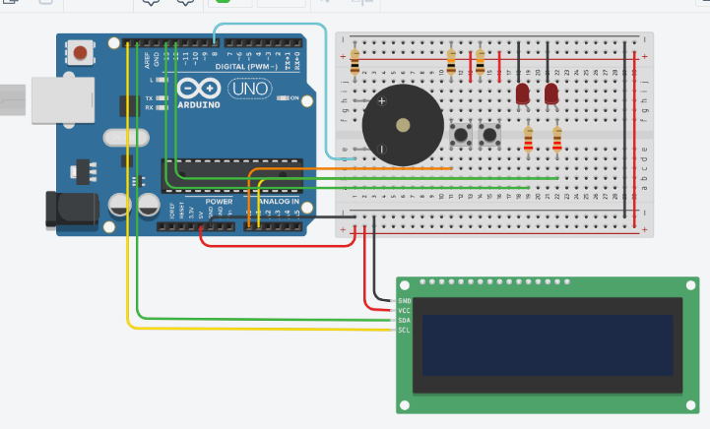

**Figure 1: Circuit Diagram**

* 1. Circuit Diagram

From the Figure 1 [4] the circuit 2 push buttons serve as the ON and OFF state of the relay module OUTPUT. The Arduino Uno will receive that OUTPUT and command the 3 components (LED, LCD and the buzzer). There are also resistors used to regulate the voltage for the specific component.

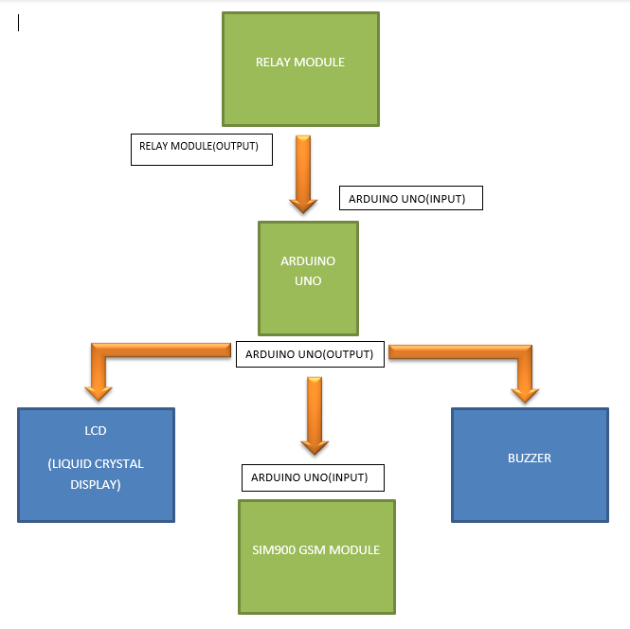

**Figure 2: Block Diagram**

* 1. Block Diagram

The Figure 2 [5] illustrates that from the relay module it sends data whether the plug is removed or plugged in. The Arduino Uno receives the data from the relay module then the LCD will display “DISCONNECTED” if the plug is unplugged and it will display “CONNECTED” is the plug is attached. The buzzer will beep when plugged and unplugged as well as the LED.

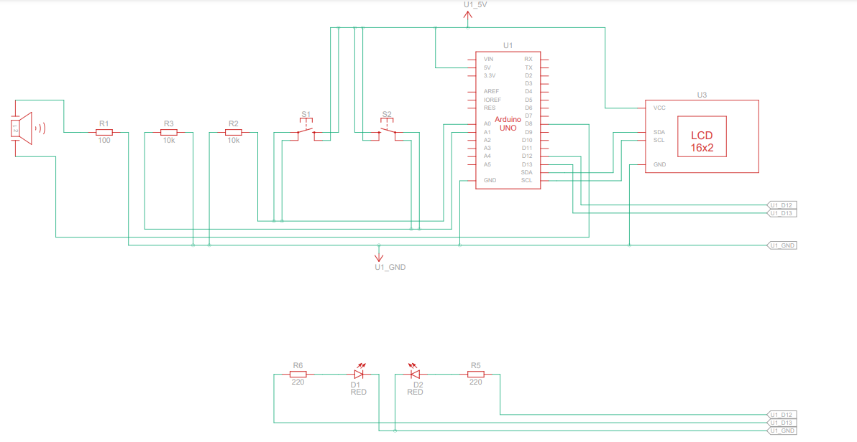

**Figure 3: Schematic Diagram**

* 1. Schematic Diagram

Figure 3 [5] shows the connection of inputs and outputs of each component. It is a fundamental two-dimensional circuit representation showing the functionality and connectivity between different electrical components. The Label of the component is revealed. Pin connections are shown in this figure.

1. ALERT NOTIFICATION SYSTEM CODE
   1. Important code

#include <Adafruit_LiquidCrystal.h>

#define disLed 13

#define conLed 12

Adafruit_LiquidCrystal lcd_1(0);

int pos = 0;

void setup()

{lcd_1.begin(16, 2);

lcd_1.print("DISCONNECTED");

pinMode(A0, INPUT);

pinMode(8, OUTPUT);

pinMode(A1, INPUT);

pinMode(disLed, OUTPUT);

pinMode(conLed, OUTPUT);

}

void loop()

{

// if button press on A0 is detected

if (digitalRead(A0) == HIGH) {

lcd_1.clear();

lcd_1.print("DISCONNECTED");

tone(8, 440, 100); // play tone 57 (A4 = 440 Hz)

digitalWrite(disLed, HIGH);

delay(1000);

digitalWrite(disLed, LOW);

}

// if button press on A1 is detected

if (digitalRead(A1) == HIGH) {

lcd_1.clear();

lcd_1.print("CONNECTED");

tone(8, 494, 100); // play tone 59 (B4 = 494 Hz)

digitalWrite(conLed, HIGH);

delay(1000);

digitalWrite(conLed, LOW);

}

delay(10); // Delay a little bit to improve simulation performance

}

* 1. Code explaination

Using the “Adafruit_LiquidCrystal.h” header file LCD can be accessed then declare necessary variables. In the void setup () the pin were defines whether in is an output or input. The loop will wait for the data when the button is pressed and do the consecutive commands for the LED, LCD and buzzer.s

REFERENCES

<bib id="bib1"><number>[1]</number>Sukanth Behera1, Saradiya Kishore Parida. 2018. IoT-based Flood Monitoring and Alerting System using Arduino Uno, Vol.09 No.03, 702-706.2018</bib>

<bib id="bib2"><number>[2]</number>Sa Kenechukwu Anolue, Chijioke Ani. REMOTE ALERT SYSTEM FOR ELECTRICITY IN PLUG MAINS. 2017. Volume 8 Issue 4. 2017 </bib>

<bib id="bib3"><number>[3]</number>Martin A. Fischler and Robert C. Bolles. 1981. Random sample consensus: a paradigm for model fitting with applications to image analysis and automated cartography. Commun. ACM 24, 6 (June 1981), 381–395. https://doi.org/10.1145/358669.358692 </bib>

<bib id="bib4"><number>[4]</number>Figure 1.<https://www.tinkercad.com/things/9ZgVldKVqVu-tremendous-juttuli/editel?sharecode=MjdNgC1b3Mi1to_zWL73XxhWg2nPI7OJBtsY8HJDiEM></bib>

<bib id="bib5"><number>[5]</number>Figure 2.<https://www.tinkercad.com/things/9ZgVldKVqVu-tremendous-juttuli/editel?sharecode=MjdNgC1b3Mi1to_zWL73XxhWg2nPI7OJBtsY8HJDiEM></bib>

<bib id="bib6"><number>[6]</number>Figure 3.<https://www.tinkercad.com/things/9ZgVldKVqVu-tremendous-juttuli/editel?sharecode=MjdNgC1b3Mi1to_zWL73XxhWg2nPI7OJBtsY8HJDiEM></bib>